A Mini Project on

“FACE RECOGNITION SYSTEM USING CNN IN DEEP LEARNING “
A Project Report submitted in partial fulfillment of the requirements for
The award of the degree of

BACHELOR OF TECHNOLOGY

In
COMPUTER SCIENCE AND ENGINEERING
(AL&ML)
By
T. SAI SREENATH 21861A6647
D. DIVYA 21861A6614
M. AKSHITHA 21861A6634
K. SAHITHI 21861A6628
K. SHIVACHARAN 21861A6627

Under the Guidance of

Mr. BURLA SRINIVAS
Assistant Professor


DEPARTMENT OF COMPUTER SCIENCE AND ENGINEERING
MOTHER THERESSA COLLEGE OF ENGINEERING & TECHNOLOGY
(Approved by AICTE, New Delhi & Affiliated to JNTUH Hyderabad)
Peddapalli (Dist.), Telangana-505174
2021-2025

DEPARTMENT OF COMUPTER SCIENCE ENGINEERING (AI&ML)
MOTHER THERESSA COLLEGE OF ENGINEERING &TECHNOLOGY

(Affiliated to JNTU Hyderabad Approved by AICTE)
PP colony, Peddapally-505172

CERTIFICATE

This is to certified to that the project report entitled “FACE RECOGNITION SYSTEM USING CNN IN DEEP LEARNING” is being submitted by team T. SAI SREENATH (21861A6647), D.DIVYA(21861A6614),M.AKSHITHA(21861A6634),K.SAHTHI(21861A6628),K.SHIVACHARAN(21861A6627),in partial fulfilment of the requirements for the award of the Degree of Master of Technology in CSE with specialization “COMPUTER SCIENCE AND ENGINEERING(AL&ML)” is Bonafide work performed by Team. The work embodied in this project report has not been submitted to any other institution for the award of any degree.

INTERNAL GUIDE HEAD OF THE DEPT.
BURLA SRINIVAS Mrs. SHABHANA
Assistant professor. Assistant Professor

PRINCIPAL EXTERNAL EXAMINER
Dr.T. SRINIVAS
PhD, MTech, MBA, MISTE, MIAENG

ACKNOWLEDGEMENT

The Satisfaction that accomplishes the successful completion of any task would be in complete without the mention of the people who made it possible and whose constant guidance and encouragement crown all the efforts with success.

It is my privilege and pleasure to express my profound sense of respect, gratitude and indebtedness of my guide Mr. BURLA SRINIVAS Assistant Professor, Department of CSE(AI&ML), MOTHER THERESSA COLLEGE OF ENGG. & TECH, for his constant guidance, inspiration, and constant encouragement throughout this project work.

I wish to express my deep gratitude to Mr. BURLA SRINIVAS, Assistant Professor & Head of CSE Department, MOTHER THERESSA COLLEGE OF ENGG &TECH, for his cooperation and encouragement, in addition to providing necessary facilities throughout the project work.

I sincerely extend my thanks to Dr.T. SRINIVAS, Principal of project work. “MOTHER THERESSA COLLEGE OF ENGG & TECH”, for his valuable suggestions in completing this project.

I would like to thank all the staff and all my friends for their good wishes, their helping and constructive criticism, which led the successful completion of this project.
Finally, I thank all those who directly and indirectly helped to me in this
regard; I apologize for not list.

T. SAI SREENATH 21861A6647
D. DIVYA 21861A6614
M.AKSHITHA 21861A6634
K. SAHITHI 21861A6628
K. SHIVA CHARAN 21861A6627

ABSTRACT

The Face Recognition System is a pivotal component of biometric security systems and has gained significant attention in recent years due to its wide range of applications in security, surveillance, and personal identification. This abstract proposes a System that aims to accurately identify individuals based on facial features extracted from images using the concepts of Deep Learning.
The System employs deep learning algorithms such as Convolutional Neural Networks (CNN) for feature extraction and classification. It is trained on a large dataset of facial images to enhance accuracy and robustness. It leverages the capabilities of OpenCV for face recognition tasks. Furthermore, it demonstrates promising results in facial recognition tasks, paving the way for enhanced security and personalized user experiences.
Keywords:Deep learning, Convolutional Neural Networks(CNN),Open CV

TABLE OF CONTENTS
S.NO CONTENTS PAGENO
- Introduction 1
  - Introduction 1
  - Purpose 2
- System Analysis 3
  - Introduction 3
  - Analysis Model 3
  - Modules of the System 3
  - Existing System 5
  - Proposed System 6
- Feasibility Study 9
  - Technical Feasibility 9
  - Operational Feasibility 10
  - Economical Feasibility 11
- Software Requirement Specification 12
  - Functional Requirements 13
  - Non-Functional Requirements 14
  - Performance Requirements 15
  - Hardware Requirements 17
  - Software Requirements 19
- System Design 20
  - Introduction 20
  - UML Diagrams 20
- Technology Description 22
  - Convolutional Neural Network 24
  - Role of Computer Vision 27
  - Keras 29
  - Tensorflow 31
- Implementation 34
- 1 Graphical User Interface 34
  - Database Connection 37
  - Bycrypt Security 38
  - Face Recognition 38
- Testing 49
  - Evaluation 49
  - Results 51
- Future Enhancements 54
- Conclusion 56
- Bibliography 57

1. INTRODUCTION

1.1 Introduction
In today's digital age, security and authentication have become paramount concerns for individuals and organizations alike. Traditional authentication methods, such as passwords and PINs, are vulnerable to various threats, including hacking and identity theft. To address these concerns, this project presents a Face Recognition System with Secure User Authentication, leveraging cutting-edge technologies in computer vision and machine learning.
Face recognition technology has gained significant attention in recent years due to its potential to provide secure and convenient authentication. This project aims to develop a comprehensive face recognition system that integrates user registration, face detection, recognition, and secure authentication. The motivation behind this project is to create a robust and efficient system that can accurately identify individuals, while ensuring the security and integrity of user data.The Face Recognition System consists of three primary components: Face Detection, Face Recognition, and Secure Authentication. The face detection module utilizes the Haar cascade classifier to detect faces in real-time video streams. The face recognition module employs a convolutional neural network (CNN) to extract facial features and match them against a database of known individuals.
Biometrics are part of the cutting-edge technology. Biometrics are the metrics related to human features. As an emerging technology, biometric systems can add great convenience by replacing passwords, helping law enforcement catch criminals and even in organizations in posting the attendance of an employee. Several types of biometric types are available like Face Recognition, Iris Recognition, Fingerprint Scanner, Voice Recognition, Hand Geometry, Behaviour Characteristics. The Face Recognition System with Secure Authentication presents a robust and efficient solution for individual identity verification. By leveraging deep learning algorithms and computer vision techniques, this system provides a secure and convenient means of authentication, eliminating the need for passwords and PINs. With its user-friendly interface and secure authentication module, this system has far-reaching applications in various industries, including finance, healthcare, and law enforcement. As technology continues to evolve, this project serves as a foundation for future advancements in face recognition and secure authentication.

1.2 Purpose
The development of a secure and efficient solution for identifying and verifying individuals through facial features. The primary objectives are to enable users to register their faces by capturing multiple images for accurate recognition, and to implement a system that can reliably identify and verify individuals. This system is designed for a wide range of applications, such as access control, surveillance, and identity verification for various sectors like banking, law enforcement, and government agencies.
In addition to face recognition, the system focuses on enhancing security through features like user authentication and password management, allowing users to securely access their accounts. Face detection and alignment algorithms are employed to ensure accurate face recognition, while a MySQL database is used for secure data storage. The system also includes capabilities for enrollment, face recognition, and secure password resets. By combining these features, the project offers a comprehensive solution for access control and identity verification.
This face recognition system has the potential to be applied in numerous areas such as smart home security, attendance tracking, and surveillance. By offering reliable and secure facial recognition, it can replace or supplement traditional authentication methods, providing a more efficient and user-friendly alternative. The integration of these functionalities ensures that the system can meet the demands of modern security and identification needs, offering both convenience and robust protection against unauthorized access.

2. SYSTEM ANALYSIS

2.1 Introduction
After analysing the requirements of the task to be performed, the next step is to analyse the problem and understand its context. The first activity in the phase is studying the existing system and other is to understand the requirements and domain of the new system. Both the activities are equally important, but the first activity serves as a basis of giving the functional specifications and then successful design of the proposed system. Understanding the properties and requirements of a new system is more difficult and requires creative thinking and understanding of existing running system is also difficult.

2.2 Analysis Model
The analysis model for aFace Recognition System typically involves several key components, ranging from data preprocessing and model design to evaluation metrics. The goal is to develop a system that can accurately and efficiently identify or verify individuals based on facial images. Below is an outline of the typical analysis model used in a face recognition project based on CNNs.

2.3 Modules of the System
The system after careful analysis has been identified interconnected modules that work together to provide a comprehensive and secure face recognition solution.

User Management Module
The User Management Module handles user registration and login functionality, ensuring secure storage of user credentials using bcrypt hashing. It validates user input, provides password reset functionality, and maintains user data integrity.

Face Recognition Module
The Face Recognition Module captures face images using a webcam, trains a Convolutional Neural Network (CNN) model using captured images, and recognizes faces in real-time using the trained model. This module forms the core of the face recognition functionality.

Image Processing Module
The Image Processing Module pre-processes face images for recognition by resizing and normalizing them. It also detects faces in images using OpenCV's Haar Cascade Classifier, ensuring accurate face detection.

Database Management Module
The Database Management Module interacts with a MySQL database to store and retrieve user credentials, face recognition model data, and label encoder information. This module ensures seamless data management and retrieval.

Graphical User Interface (GUI) Module
The GUI Module provides a user-friendly interface using Tkinter, handling user input and feedback. It ensures an intuitive and engaging user experience.

Security Module
The Security Module prioritizes security by hashing passwords using bcrypt and validating user input to prevent SQL injection and other security vulnerabilities.

Face Capture Module
The Face Capture Module handles face image capture using OpenCV and saves captured images to a directory. This module facilitates the collection of face data for model training.

Model Training Module
The Model Training Module trains the CNN model using captured face images and saves the trained model and label encoder. This module enables the face recognition system to learn and adapt.

Real-time Recognition Module
The Real-time Recognition Module recognizes faces in real-time using the trained model and displays recognition results on the GUI. This module provides instantaneous face recognition capabilities.

2.4 Existing System
There are many Face Recognition Systems which refer to current biometric and traditional methods of identity verification, such as fingerprint recognition, iris scanning, and passwordbased systems. In the case of face recognition, older systems may use basic image recognition techniques that are less accurate and slower compared to more advanced solutions. Traditional password systems, which remain the most common form of authentication, rely on users remembering passwords, making them vulnerable to security risks like hacking or forgetting. Other existing systems, such as physical security measures (ID cards, PINs, or access cards), are also commonly used but have their own drawbacks, such as the risk of loss, theft, or misuse. While biometric systems like fingerprint or iris recognition offer higher security, they can be slow or error-prone, especially when influenced by environmental factors or user issues. Overall, these existing methods often lack the efficiency, accuracy, and security provided by more modern face recognition systems that integrate advanced AI, machine learning, and computer vision technologies for real-time, high-accuracy identification and verification.

Disadvantages
Generally,older face recognition technologies often suffer from poor accuracy due to lowquality cameras, inadequate lighting, and limited training data. These systems struggle with variations in angles, lighting, and facial expressions, leading to errors. Traditional methods like passwords and PINs are vulnerable to hacking, phishing, and theft, while basic face recognition systems may lack modern anti-spoofing features, making them susceptible to tricks like photos or 3D models.
Additionally, many older systems experience slow processing speeds, causing delays, especially in real-time applications. Traditional biometric systems, such as fingerprint or iris recognition, may also be inconvenient to use, particularly if the sensors are unresponsive due to dirt, moisture, or physical injury. Furthermore, existing face recognition systems often lack scalability, meaning they can't efficiently handle large databases or high volumes of users, resulting in slower performance as usage grows. High maintenance costs are also a concern, as older systems require specialized hardware and infrastructure that can be expensive to maintain.
Privacy and adaptability issues also persist with older systems. Many lack robust data encryption, leaving personal data vulnerable to breaches. Traditional systems may struggle with environmental changes, such as changes in lighting or facial appearance, often requiring users to re-enroll. Lastly, many systems do not offer real-time monitoring, which can result in delayed responses to security threats, leaving vulnerabilities exposed.

2.5 Proposed System
The proposed Face Recognition System (FRS) offers a secure and efficient way to identify and verify individuals using advanced technologies like AI, computer vision, and machine learning. Unlike traditional methods such as passwords or PIN codes, the system uses facial features to authenticate users, providing a more reliable and safer alternative. The FRS works in real-time, capturing and analyzing facial data to determine a person's identity quickly and accurately.
The system consists of several modules that work together to perform face detection, recognition, and identity verification. The first module, Face Detection, scans images or video in real-time to identify faces, ensuring the system only focuses on relevant areas. Once a face is detected, the Face Recognition module compares it to stored templates in the database, which are created during the user registration process by capturing unique facial features. If a match is found, the system confirms the person’s identity, granting access or authentication.
For new users, the FRS includes a Registration module where individuals can input their facial data and personal information. This data is securely stored in the system’s database for future use. Additionally, the system features a Password Recovery option, allowing users to regain access through face recognition, offering a more secure alternative to traditional recovery methods. All user data, including facial templates, is encrypted and stored securely, ensuring the protection of sensitive information while providing a fast and convenient way to verify identities.
Advantages

Enhanced Security
This significantly enhances security by offering a biometric method of identification, which is far more difficult to spoof or bypass than traditional methods like passwords or PIN codes.
Unlike passwords, which can be forgotten, guessed, or stolen, facial features are unique to each individual and nearly impossible to replicate. This makes the system highly secure and reduces the risk of unauthorized access. Additionally, the FRS offers real-time monitoring and immediate detection of potential security breaches, providing an extra layer of protection against unauthorized attempts or suspicious activity.

Efficient Identification
One of the key advantages of the FRS is its ability to quickly and accurately identify individuals in real-time. The system automates the identification process, eliminating the need for time-consuming manual verification. When a person approaches the system, their face is detected and matched with the database within seconds, allowing for swift access. This efficiency is particularly beneficial in high-traffic environments where quick identification is essential, such as airports, offices, or event venues. The system minimizes wait times and streamlines workflows, making it an ideal solution for fast-paced or high-security areas.

Real-Time Monitoring
It is a key feature of the FRS that enhances its effectiveness in detecting and responding to security threats. The system continuously scans and analyzes the environment, looking for faces that match stored templates. In the event of suspicious activity, such as an unrecognized face or multiple failed login attempts, the system can trigger instant alerts to security personnel. This real-time capability allows for prompt responses to potential threats, improving overall security. Whether it’s a physical building, an event venue, or a restricted area, the FRS helps maintain constant vigilance and proactive security monitoring.

Cost-Effective
The proposed system is a cost-effective solution for organizations looking to improve security without investing heavily in physical security measures or personnel. Traditional security systems, such as card-based access control or staffed security checkpoints, often require ongoing maintenance, physical infrastructure, and human resources. In contrast, the FRS reduces or eliminates the need for such measures, offering a more affordable long-term solution. The system’s automation further reduces costs by eliminating the need for manual verification, allowing staff to focus on more critical tasks and reducing labor expenses.

Scalability
The system is highly scalable, meaning it can handle a growing number of users and face templates without compromising performance. As organizations expand or the user base increases, the system can easily accommodate additional individuals without the need for major infrastructure changes. The ability to store and manage a large number of face templates in a secure database ensures that the system remains efficient and responsive even as the dataset grows. This scalability makes the FRS a suitable solution for businesses, government agencies, or public services that need to manage thousands or even millions of users.

3. FEASIBILITY STUDY
A feasibility study is a crucial first step in assessing the viability of a proposed project or system. It provides an overview by evaluating the technical, operational, and economic aspects of the solution, ensuring it is practical, sustainable, and aligned with available resources. The study aims to determine if the project can be developed with the current expertise and resources, if it fits within the organization's operations, and whether it is financially viable. It considers constraints like time, budget, and technology limitations, ensuring that the project is realistic and achievable. Conducting a feasibility study helps stakeholders make informed decisions, guiding them in determining whether the project should proceed or be reconsidered.
A preliminary investigation often begins the feasibility study, helping to define the project's scope, identify key issues, and assess its likelihood of success. This phase focuses on evaluating technical feasibility (whether the necessary technology is available), operational feasibility (whether the system can integrate into current operations), and economic feasibility (whether the project fits within budget and delivers a reasonable return). By carefully considering these factors, the study provides a comprehensive understanding of the project's strengths, weaknesses, and risks. This clarity helps ensure the project has a clear, structured path forward and minimizes the likelihood of encountering major setbacks during development.

3.1 Technical Feasibility
Technical feasibility is a crucial initial step in evaluating a project once it has been defined. For large-scale engineering projects, specialized consulting firms with large teams of engineers and technicians typically conduct these technical assessments.
When performing a technical feasibility study, several important factors need to be considered. These include the availability of technical resources, the flexibility of the proposed system, and its accuracy and reliability. Additional considerations include data security, response time, human factors (such as user experience), and the economic aspects of the solution. Assessing these factors ensures that the system will meet the required performance standards and can be successfully developed, deployed, and maintained over time.

Technical feasibility performs the following tasks:
- Verification of technical resources like hardware and software.
- Evaluation of the system's flexibility for future expansion and updates, such as the potential for incorporating additional facial recognition features or adopting new algorithms.
- Assessment of the system's accuracy and reliability, including the effectiveness of face detection algorithms and the accuracy of facial recognition under various conditions.
- Identification of potential risks, such as hardware limitations or privacy concerns, and proposed solutions like encryption or distributed processing to mitigate these risks.
The technical feasibility assessment focuses on understanding the organization's current technical resources and determining how well they align with the requirements of the proposed system. It involves evaluating the existing hardware and software to see if they can support the system's needs and ensure successful implementation.

3.2 Operational Feasibility
Operational feasibility evaluates how well the proposed software can perform the tasks necessary to address business problems and meet user requirements. It depends on the availability of human resources, such as the software development team, and considers whether the system will function effectively once it is developed and deployed.
In this phase, we examine various operational factors, such as manpower, time, and other resources. The most operationally feasible solution is the one that requires the least amount of operational resources while still meeting the objectives. The solution must also be practical to implement within the current operational environment. Operational feasibility ensures that the proposed system can be integrated smoothly into existing workflows and that user objectives can be achieved without disrupting ongoing operations.
- The software development team has identified the high-priority problems in user requirements, such as ensuring high accuracy in facial recognition and addressing security concerns.
- The solution proposed by the development team has been accepted, as it addresses both the technical and operational needs of the system.
- User adaptability has been analyzed, and the system has been designed to be userfriendly, with sufficient training provided to ensure smooth adoption.
- The organization is satisfied with the proposed solution, as it meets the outlined business objectives and functional requirements.
- Clients have been actively involved in the planning and development process, ensuring the system meets their specific needs.
- The development team has verified that no significant problems are anticipated with the proposed system, ensuring smooth operation post-deployment.

3.3 Economical Feasibility
Economic feasibility assesses whether the proposed software can generate sufficient financial benefits for the organization to justify its costs. It involves evaluating the expenses associated with developing the software, including the costs of the development team, hardware, software, and conducting the feasibility study. This analysis helps determine whether the financial investment in the project will lead to a positive return and if the benefits outweigh the costs.
Economically, this project is completely feasible because its development costs are minimal while providing significant long-term value, including improved security and operational efficiency. The system is tailored to meet client requirements, ensuring a high return on investment by streamlining processes and reducing manual labor.
The new system is economically feasible only when the financial benefits are more than the investments and expenditure. Economic feasibility determines whether the project goal can be within the resource limit allocated to it or not. It must determine whether it is worthwhile to process with the entire project or whether the benefits obtained from the new system are not worth the costs. Financial benefits must be equal or exceed the costs.
Software is said to be economically feasible if it focuses on the issues that are listed below :
- The cost incurred on software development relative to the long-term financial benefits for the organization.
- The cost required to conduct a full software investigation, including requirements elicitation and analysis.
- The cost of hardware, software, development team, and training.
- The cost to conduct a comprehensive system investigation.
- The cost of hardware and software needed for the specific class of application.
- The cost of development tools used in the project.
- The cost of maintenance and ongoing support after deployment.
- The scalability and potential for future growth, ensuring long-term value.
- The alignment of the system with organizational business goals, enhancing overall operational efficiency.

4. SOFTWARE REQUIREMENT SPECIFICATION
The primary purpose of this document is to provide an overview of the analysis and requirements of the existing system or situation, as well as to define the operational characteristics of the system. It plays a crucial role in the development life cycle, outlining the complete set of system requirements. Intended for use by the development team, this document serves as a foundation during the testing phase. Any modifications to the requirements in the future will need to go through a formal change and approval process.

4.1 Functional Requirements
The Face Recognition System is designed to provide a seamless user experience by integrating secure authentication and facial recognition technologies. The system ensures that user data is managed securely while offering an easy-to-use interface for registration, login, and face recognition. It aims to improve the efficiency of identity verification by automating the process of face registration and recognition. The following functional requirements outline the essential features of the system:
- The system will allow new users to register with a unique username and password.
- The system willvalidate user input data during registration.
- The system will store user credentials securely in the database.
- The system will authenticate users based on their username and password during login.
- The system will grant access only to authorized users.
- The system will capture and store face images for registered users.
- The system will detect and extract facial features from the captured images.
- The system will identify individuals based on their facial features during face recognition.
- The system will display the recognized user's name after a successful match.
- The system will store user data and face images securely in a MySQL database.
- The system will ensure data integrity and security within the database.
- The system will provide an option for users to reset their passwords if forgotten.
- The system will display messages for successful registration, login, and face recognition.
- The system will display error messages for invalid input or system failures.
- The system will provide an intuitive graphical user interface (GUI) for user interaction.
4.2 Non-Functional Requirements

Security
User data and passwords are protected through encryption and secure authentication protocols, preventing unauthorized access.

Usability
The interface is intuitive and easy to navigate, with clear instructions and feedback to guide users.

Reliability
It consistently delivers accurate results, with built-in mechanisms to minimize errors and ensure stability.
Scalability
It can handle increasing user numbers and database sizes without compromising performance.

Integrity
The degree to which the data maintained by the software system are accurate, authentic, and without corruption.

Safety
The degree to which a software system prevents harm to people or damage to the environment in the intended context of use.

Compatibility
It operates across multiple operating systems and supports various hardware configurations for flexible deployment.

Usability
The ease with which the user is able to learn, operate, prepare inputs, and interpret outputs through interaction with a system.

Flexibility
The ease with which the software can be modified to adapt to different environments, configurations, and user expectations.

4.3 Performance Requirements
Performance requirements are the requirements that are not directly concerned with the specific services delivered by the system to its users. They may define constraints on the system implementation such as the capabilities of input devices or the data representation used in interfaces with other system.

Security
The Security of the system is a top priority, ensuring both high-level protection and data integrity. By using secure authentication methods, such as facial recognition technology, the system prevents unauthorized access and minimizes the risk of data breaches. Only authorized individuals, whose facial data is securely stored in the database, are allowed to access the system. This ensures that sensitive information is protected at all times, offering peace of mind to both users and administrators.

Access Permission
It is handled through advanced facial recognition technology, which grants or denies access based on the verification of facial data. The system stores authorized individuals' facial data in a secure database, ensuring that only those whose faces match the stored records can gain access. This method not only simplifies the access control process but also ensures that it is both secure and efficient, minimizing the risk of unauthorized entry.

Maintainability
The system is designed to be easy to maintain and update, offering a cost-effective solution for long-term use. Its architecture allows for efficient processing and minimal downtime during maintenance, ensuring that regular updates or fixes can be implemented without significant disruption. The system is optimized to perform reliably over time, reducing the need for frequent repairs or overhauls.

Reliability
The system shall beconsistently perform its intended function without failure over a specified period of time and under normal operating conditions

Performance
The system is optimized through the use of a high-performance facial recognition algorithm that ensures rapid processing and response times. The system handles user input and requests efficiently, making timely access control decisions based on accurate facial recognition. This high level of performance contributes to a smooth and seamless user experience, with fast and accurate authentication processes.

4.4 Hardware Requirements
The hardware requirements required to run and create the Face Recognition System is described below:
- Webcam
- Computer Desktop or Laptop

Webcam
A webcam is essential for capturing images, and its performance is influenced by factors like mouse sensitivity and camera resolution. The webcam continuously provides real-time images whenever the computer is on. The system is designed to detect and recognize facial features for face recognition, allowing it to identify individuals based on their appearance.

Computer desktop or laptop
A computer, whether a desktop or laptop, is used to run a program that processes and displays the images captured by the camera. For added portability, a laptop, which is compact, lightweight, and affordable, can be used instead of a desktop.

4.5 Software Requirements
These are the essential software requirements that are necessary to build and deploy the Deep Learning model and the web application.
Python is the primary programming language used for developing the face recognition system. It is widely used in the field of artificial intelligence and machine learning due to its simplicity, versatility, and extensive support for libraries and frameworks. Python's syntax is beginner-friendly, making it ideal for rapid prototyping and development. With its large community and wealth of machine learning libraries, Python is the most suitable language for implementing the system's face recognition functionality.
4.5.1 Libraries and Frameworks:
- OpenCV :
OpenCV is an open-source computer vision library that plays a key role in tasks such as face detection, image processing, and feature extraction. OpenCV provides powerful functions for handling images and videos, which are essential for processing facial data in the system. This library allows the system to detect faces in real-time from a camera feed or image and is critical for preprocessing input data.
- TensorFlow:
TensorFlow is an open-source deep learning framework developed by Google. It is used for building and training machine learning models, particularly deep neural networks. In the case of face recognition, TensorFlow provides the tools to create and optimize the convolutional neural network (CNN) that will identify and verify faces. It supports GPU acceleration, making it highly efficient for training large-scale models.
- Keras:
Keras is a high-level neural networks API written in Python and integrated with TensorFlow. It simplifies the process of building, training, and testing deep learning models. Keras provides an easy-to-use interface for defining layers, loss functions, and optimizers, making it ideal for quickly developing and experimenting with machine learning models. Keras is used in the project to design and train the face recognition model.

- NumPy:
NumPy is a powerful library for numerical computations in Python. It provides support for large, multi-dimensional arrays and matrices, which are essential for manipulating data and performing mathematical operations. In face recognition systems, NumPy is used for processing image data, performing matrix operations, and handling large datasets, which are core tasks in training deep learning models.
- MySQL Connector:
MySQL Connector is a Python library that facilitates interaction with a MySQL database. For the face recognition system, MySQL is used to store user data, including facial feature vectors, personal information, and authentication data. This connector allows seamless communication between the application and the database, enabling the system to retrieve and store user information as part of the identification and verification process.
- Tkinter:
Tkinter is Python's standard library for creating graphical user interfaces (GUIs). It is a simple and lightweight toolkit that allows developers to build windows, buttons, and other UI elements for user interaction. In the face recognition system, Tkinter is used to create a user-friendly interface where users can interact with the system, upload images, and view recognition results. It provides a basic but effective way to present the application in a desktop environment.
- Pillow:
Pillow is a Python Imaging Library (PIL) fork that provides tools for opening, manipulating, and saving image files in various formats. It is used for image processing tasks such as resizing, cropping, or converting images to the appropriate format for recognition.
- Scikit-learn:
Scikit-learn is a widely used library for machine learning in Python. It provides simple and efficient tools for data mining and data analysis. Scikit-learn can still play a role in tasks like feature extraction, clustering, and classification, which may complement the face recognition process. It is used for machine learning tasks like data preprocessing and feature scaling, which help improve the accuracy of the model.

- Bcrypt:
Bcrypt is a library used for password hashing and encryption. It is essential for securing user authentication data in the face recognition system. Bcrypt ensures that user passwords are stored securely by hashing them before storing them in the database. This protects sensitive data from unauthorized access and makes the system more secure, ensuring that users' personal information remains safe.

4.5.2 System application
This application features a user-friendly interface built with Tkinter and and OpenCV for face detection and recognition. TensorFlow trains a CNN model for accurate face identification. Users can register by creating a username and password, with data securely stored in a MySQL database, and register their faces with multiple images. The system authenticates users using the CNN model, displaying the corresponding username. A login feature allows access with credentials, and forgotten passwords can be reset for secure and convenient authentication.

5. SYSTEM DESIGN

5.1 Introduction
Software design is a fundamental aspect of the software engineering process, serving as the blueprint for building any software system, regardless of the development methodology or application area. It marks the beginning of the development phase, following the specification and analysis of system requirements. The designer's primary objective is to create a model or representation of the system that can be built later. System design is the first of three technical stages—design, coding, and testing—that are essential for constructing and verifying software.
During the design phase, the system’s data structure, program structure, and procedural details are progressively refined, reviewed, and documented. Design can be approached from both a technical and a project management perspective. From a technical viewpoint, system design involves four main activities: architectural design (defining the overall structure of the system), data structure design (organizing data efficiently), interface design (ensuring proper interaction between components), and procedural design (detailing the algorithms and processes to be followed).

5.2 UML diagrams
A UML diagram is a diagram based on the UML (Unified Modeling Language) with the purpose of visually representing a system along with its main actors, roles, actions, artifacts or classes, in order to better understand, alter, maintain, or document information about the system. Simply put, UML is a modern approach to modeling and documenting software. In
fact, it’s one of the most popular business process modelling techniques.
It is based on diagrammatic representations of software components. As the old proverb says:
“a picture is worth a thousand words”. By using visual representations, we are able to better understand possible flaws or errors in software or business processes.
UML diagrams are an invaluable tool in the field of software engineering. They provide a standardized, visual approach to modeling systems, helping teams better communicate, understand, and document complex designs. Whether used for modeling software structure, documenting workflows, or improving business processes, UML diagrams are essential for developing high-quality, maintainable, and efficient systems.

Use Case
A use case diagram at its simplest is is a visual representation that illustrates the interactions between users (actors) and a system. It captures the functional requirements of a system, showing how different users engage with various use cases, or specific functionalities, within the system. Use case diagrams provide a high-level overview of a system’s behavior, making them useful for stakeholders, developers, and analysts to understand how a system is intended to operate from the user’s perspective, and how different processes relate to one another. They are crucial for defining system scope and requirements.

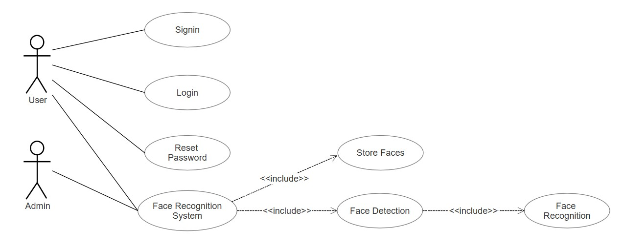
Fig 5.2.1: Use Case Diagram

Class
Class diagram consists of classes, interfaces, associations, and collaboration. Class diagrams basically represent the object-oriented view of a system, which is static in nature. The class diagram depicts a static view of an application. It represents the types of objects residing in the system and the relationships between them. A class consists of its objects, and also it may inherit from other classes. A class diagram is used to visualize, describe, document various different aspects of the system, and also construct executable software code.
It shows the attributes, classes, functions, and relationships to give an overview of the software system. It constitutes class names, attributes, and functions in a separate compartment that helps in software development. Since it is a collection of classes, interfaces, associations, collaborations, and constraints, it is termed as a structural diagram.

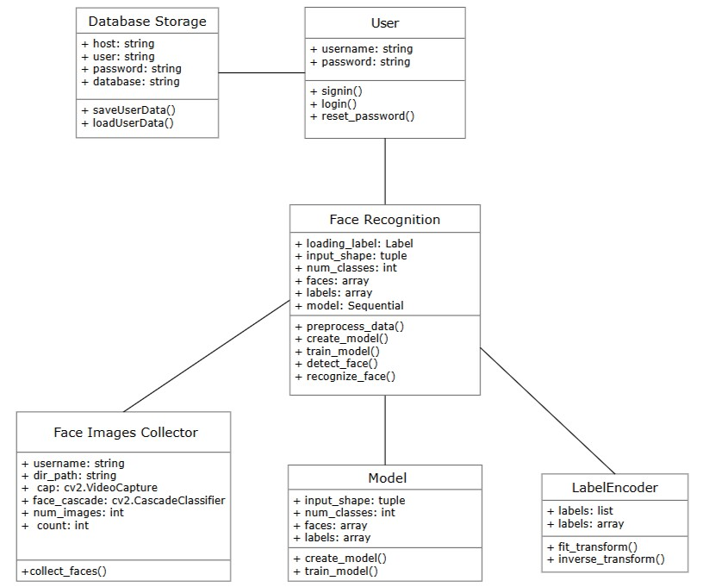
Fig 5.2.2: Class diagram

Activity
An activity diagram is a behavioral diagram i.e. it depicts the behavior of a system. An activity diagram portrays the control flow from a start point to a finish point showing the various decision paths that exist while the activity is being executed.
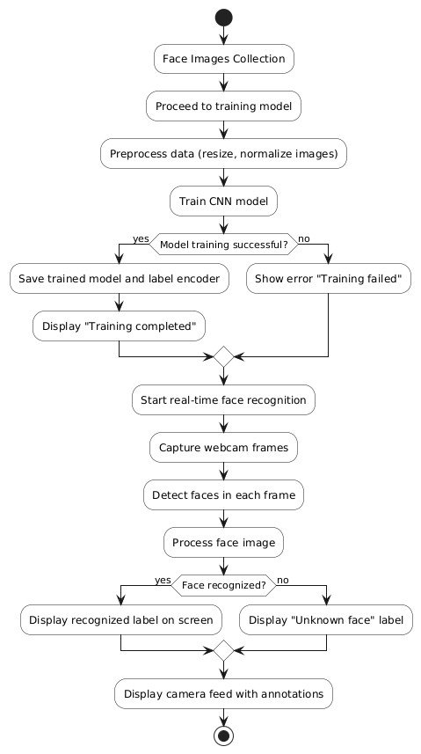

Fig 5.2.3: Activity Diagram

6.Technology Description
Face recognition involves identifying or verifying an individual from an image or video stream. The main challenge is to extract relevant features that are invariant to variations like changes in lighting, facial expressions, pose, and even aging. A CNN-based approach solves this by automatically learning these features during training.

6.1 Convolutional Neural Network
Convolutional Neural Networks (CNNs) are a specialized class of deep learning algorithms designed to process data that has a grid-like structure, such as images. They are inspired by the human visual system, particularly the structure and function of the visual cortex, which is responsible for processing visual information. The architecture of CNNs mimics the hierarchical pattern of visual processing in the brain, where simple features are detected in early layers, and more complex patterns are recognized in deeper layers. This ability to automatically learn and extract features from raw data makes CNNs particularly powerful for tasks like image recognition and classification.

Essential Layers of CNN
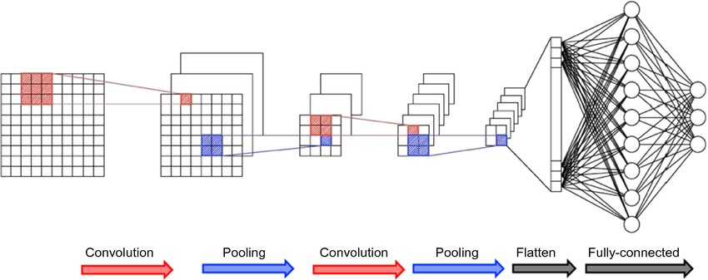
Fig 6.1.1:CNN Architecture

I. Convolutional Layer
The objective of the Convolution Operation is to extract the high-level features such as edges, from the input image. CNNs need not be limited to only one Convolutional Layer. Conventionally, the first Convolutional Layer is responsible for capturing the Low-Level features such as edges, colour, gradient orientation, etc. With added layers, the architecture adapts to the High-Level features as well, giving us anetwork which has the wholesome understanding of images in the dataset, similar to how we would.
Each image is namely represented as a 3D matrix with a dimension for width, height, and depth. Depth is a dimension because of the colours channels used in an image (RGB). Generally, numerous convolutions on the input is performed, where each operation uses a different filter. This results in different feature maps. In the end, we take all of these feature maps and put them together as the final output of the convolution layer.
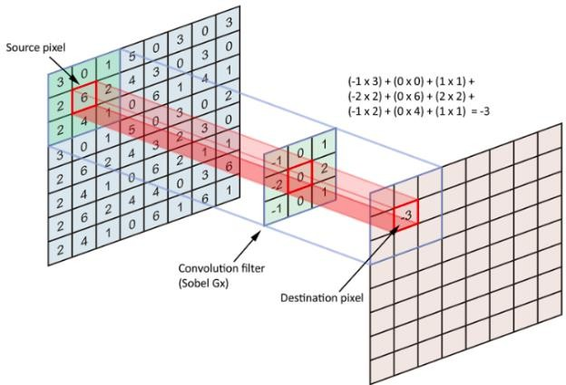

Fig 6.1.2: Operation of Convolutional Layer

II. Max Pooling Layer
The Pooling layer is responsible for reducing the spatial size of the convolved feature. This is to decrease the computational power required to process the data through dimensionality reduction. Furthermore, it is useful for extracting dominant features which are rotational and positional invariant. Hence, maintaining the process of effectively training of the model.
Max Pooling also performs as a Noise Suppressant. It discards the noisy activations altogether and also performs de-noising along with dimensionality reduction. The Figure
6.1.3 illustrates the max pooling operation.

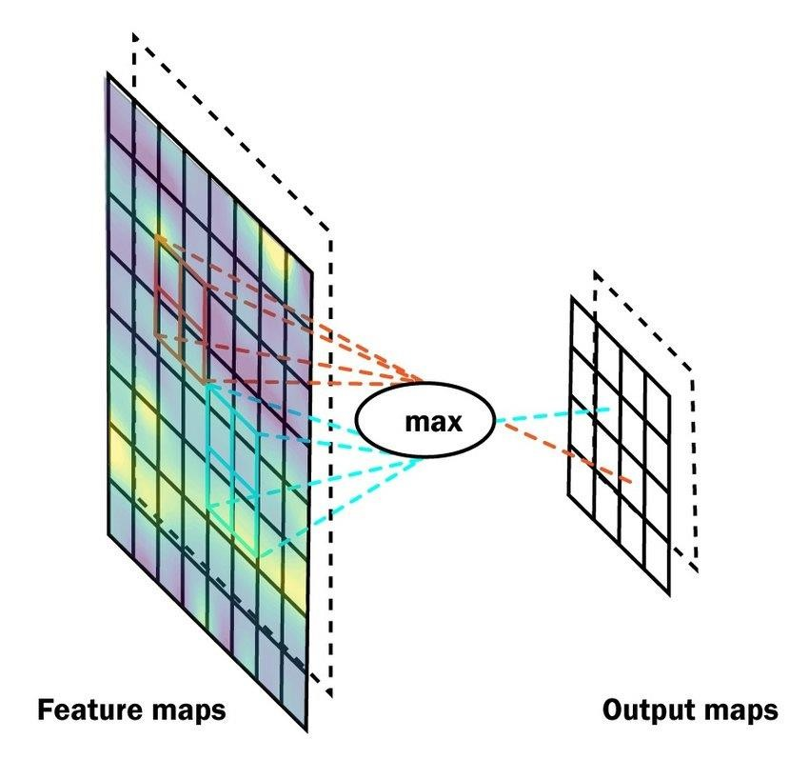
Fig 6.1.3 : Operation of Max Pooling Layer

III. Flatten Layer
The resulting feature maps are flattened into a one-dimensional vector after the convolution and pooling layers so they can be passed into a completely linked layer for categorization or regression.
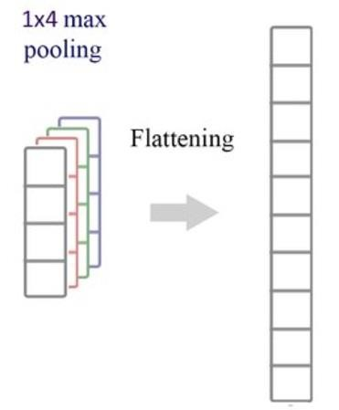
Fig 6.1.4 : Operation of Flatten Layer

IV. Fully Connected Layer
It takes the input from the previous layer and computes the final classification or regression task.
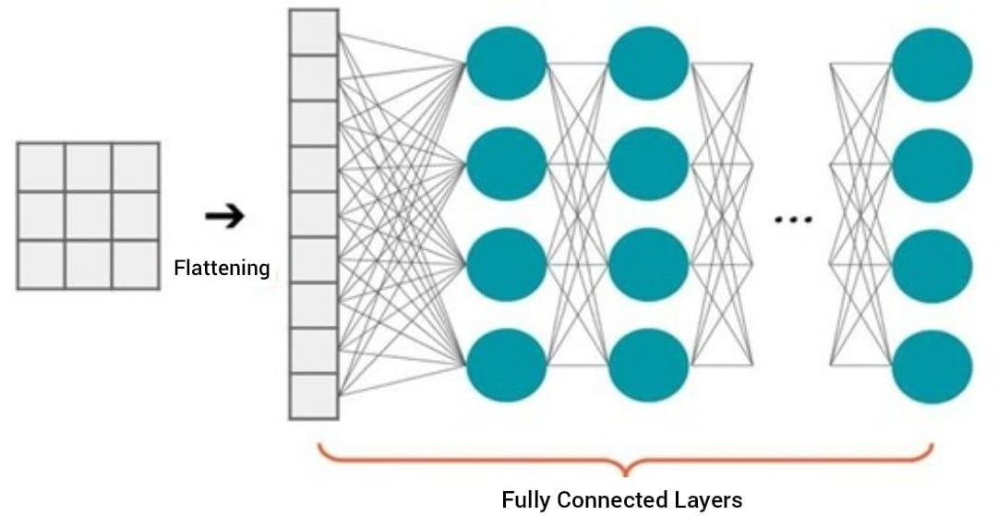
Fig 6.1.5 : Operation of Fully Connected Layer
6.2 Computer Vision

Face Detection with OpenCV
OpenCV includes pre-trained models for face detection ,which can detect faces in real-time video feeds or still images. This is the first step in any face recognition system: detecting and isolating the face region.
The Haar Cascades is the pretrained model used for developing the system.
- Haar Cascades is a specific machine learning-based method used for object detection, particularly for detecting faces in images or video.
- It uses a set of pre-trained classifiers based on Haar-like features and a multi-stage classification process called a "cascade."
The Haar Cascades is a classical machine learning technique used for object detection, and it's especially popular for tasks like face detection. The method is based on the use of Haarlike features, which are simple rectangle-based features that can efficiently represent the structure of an object, such as a face, in an image.
The key idea behind Haar Cascades is to use a sliding window approach combined with the concept of features that capture patterns in images.

cv2.CascadeClassifier:
OpenCV provides the cv2.CascadeClassifier class, which is used to load the Haar Cascade XML file and apply it to images or video. The class allows you to load a pre-trained Haar Cascade model and use it to detect objects (like faces) by applying the sliding window technique to scan images.

Facial Landmark Detectionwith OpenCV
OpenCV provides tools for detecting key facial landmarks, such as the eyes, nose, mouth, and jawline, which are crucial for various face-related tasks like recognition and alignment. These landmarks are detected using pre-trained models like the dlib shape predictor or OpenCV's own facial landmark detectors.
Facial landmark detection is essential for various applications, including face alignment and pose normalization, which help to improve the accuracy and robustness of face recognition systems.

Real-time Processing with OpenCV
OpenCV excels in real-time video stream processing, making it ideal for applications that require continuous and fast face detection and recognition.
Efficient Video Stream Processing: OpenCV is optimized for real-time video and image processing, enabling it to handle live video feeds efficiently. When used in face recognition systems, OpenCV first detects faces in the video feed, then isolates and preprocesses them (e.g., resizing, converting to grayscale) before passing them to a CNN model for further analysis and recognition.
Security Systems: OpenCV’s real-time face detection is essential for security applications, such as surveillance systems. The system can instantly identify or authenticate individuals based on live video feeds, enhancing the security of public and private spaces.
Interactive Systems: In interactive systems like virtual assistants, gaming applications, or smart kiosks, real-time face detection allows the system to quickly detect and react to the presence of users. This enables personalized interactions based on face recognition.
Speed Optimization: Real-time face detection is vital for maintaining system responsiveness. By processing and recognizing faces quickly, OpenCV ensures that systems, whether on mobile devices or high-performance computers, provide an efficient user experience.

6.3 Keras
Keras provides a high-level interface to create CNN architectures quickly and easily. It abstracts away the complexity of lower-level operations, allowing developers to focus on the design of the network. This is especially useful for building complex face recognition models that require specific layer configurations.
Model Building:
Keras provides an intuitive, high-level API to define ConvolutionalNeural Networks (CNNs), the architecture commonly used for face recognition. With Keras, you can quickly experiment with different layers, such as convolutional, pooling, and dense layers, to design the optimal model for the task at hand.
- Layer Abstraction: Keras provides predefined layers like Conv2D, MaxPooling2D, Flatten, and Dense, which are commonly used in CNNs. You can stack these layers to build a model architecture suitable for face recognition.
- Sequential and Functional API:Keras supports two ways to define models:
  - Sequential API: A simpler method where layers are stacked sequentially, ideal for simpler architectures.
  - Functional API: A more flexible approach where you can define complex architectures with multiple inputs, outputs, or shared layers. This flexibility is often required for advanced face recognition models.
Rapid Prototyping:
With Keras, developers can quickly iterate on different architectures, testing various configurations without delving into low-level details, making it highly suited for research and rapid development.
- Model Flexibility: With Keras, developers can quickly experiment with different CNN architectures, layer types, and configurations. This is vital in face recognition tasks because you may need to fine-tune the model architecture to optimize accuracy and performance.
- Easy Adjustments: Changing hyperparameters, such as the number of layers, filter sizes, and learning rates, is straightforward in Keras. This makes it easy to tweak models to achieve the best face recognition performance.
Optimizers and Custom Loss Functions:
- Optimizers: Keras provides several optimizers, such as Adam which can be used to minimize the loss function during training. The right choice of optimizer can significantly affect the performance of the face recognition model.
- Custom Loss Functions: Keras allows you to define custom loss functions, which is important in tasks like face recognition where contrastive loss, triplet loss, or softmax loss might be used instead of typical classification loss functions like categorical cross-entropy.
Integration with TensorFlow
- Keras operates as an interface for TensorFlow, the backend engine that handles the heavy computational tasks of training and inference. TensorFlow ensures that your CNN models run efficiently, especially when working with large datasets or deploying models to GPUs for faster processing.
- Keras also allows you to take advantage of TensorFlow’s advanced features, such as distributed training, model optimization, and deployment to different platforms.

6.4 TensorFlow
Backend Engine for Training and Inference
- Efficient Computation: TensorFlow is the backbone for performing the heavy computations required by Convolutional Neural Networks (CNNs). It handles tasks such as tensor manipulation (for input data), matrix operations (for convolution and pooling layers), and backpropagation (for optimizing weights). These computations
are computationally intensive, especially when training deep CNNs for face recognition.
- GPU and TPU Support: TensorFlow is optimized for parallel processing, meaning it can leverage GPUs (Graphics Processing Units) or TPUs (Tensor Processing Units) to accelerate training and inference. This is essential when working with large datasets or deep CNN architectures in face recognition, which may involve millions of parameters and require substantial computational power for real-time performance.
Model Training and Optimization
- Automatic Differentiation: TensorFlow automatically computes gradients using backpropagation and automatic differentiation. This allows for efficient optimization of the model during training, ensuring that the CNN learns to recognize faces accurately.
- Scalable Training: TensorFlow supports distributed training, which allows you to train large models across multiple GPUs or even multiple machines. This is beneficial when dealing with large datasets for face recognition, ensuring faster training times and scalability.
- Custom Optimizers: TensorFlow provides access to a variety of optimizers , allowing you to fine-tune how the model learns. In face recognition, choosing the right optimizer can significantly affect convergence speed and model performance.
- Custom Loss Functions: In tasks like face recognition, standard loss functions such as categorical cross-entropy may not be ideal. TensorFlow allows you to define custom loss functions, such as contrastive loss or triplet loss, which are better suited for tasks like face verification or identification.
Deep Learning Architecture and Flexibility
- Support for Complex Architectures: TensorFlow allows you to define and train complex CNN architectures, which are commonly used for face recognition. These architectures typically consist of multiple convolutional, pooling, and fully connected layers. TensorFlow provides the flexibility to design networks with any number of layers, as well as advanced layers like BatchNormalization and Dropout for better generalization and regularization.
- Custom Models: TensorFlow's Keras API provides a high-level interface to design custom models for face recognition, but TensorFlow also allows you to directly manipulate lower-level components of the model. This is useful for fine-tuning specific aspects of the architecture or implementing custom CNN components.
Data Pipeline and Preprocessing
- Data Input and Augmentation: TensorFlow makes it easy to load and preprocess image data for face recognition. You can use TensorFlow's Dataset API to efficiently load large datasets and apply transformations such as data augmentation (e.g., rotations, flips, and scaling) during training. This helps increase the diversity of your training set and improve model robustness to different facial poses, lighting conditions, and orientations.
- Input Pipeline: TensorFlow provides tools to efficiently handle input pipelines, especially when working with large-scale image data. You can preprocess images to the correct format, normalize pixel values, and batch the data for efficient GPU processing.
Embeddings and Face Verification
- Embeddings: In face recognition tasks, CNNs typically generate embeddings or feature vectors that represent each face in a lower-dimensional space. These embeddings capture the key features of the face, and TensorFlow facilitates the extraction and manipulation of these features.
- Face Verification: For face verification (i.e., determining whether two images are of the same person), TensorFlow helps in comparing the embeddings generated by the CNN. The embeddings can be compared using metrics like cosine similarity or Euclidean distance, allowing you to measure the similarity between faces.

Integration with Other Tools
- OpenCV Integration: TensorFlow can be integrated with other libraries, such as OpenCV, which is commonly used for face detection and preprocessing. In a complete face recognition pipeline, OpenCV handles detecting faces in an image or video stream, and TensorFlow performs the recognition part using the CNN.
- Multi-Task Learning: In some applications, face recognition may involve multiple tasks, such as facial expression recognition, age and gender prediction, or emotion detection. TensorFlow provides flexibility for multi-task learning, where a single model can be trained to handle multiple face-related tasks simultaneously.

7. Implementation
The comprehensive implementation of a Face Recognition System using Python, OpenCV, and Tkinter for the graphical user interface (GUI) is developed.

7.1 Graphical user interface
The face recognition system's GUI is built with Tkinter, a Python library, and includes components like a root window, frames, labels, buttons, entry fields, and images displayed using PIL (Python Imaging Library). These elements are arranged into frames for specific functionalities, such as sign-in, sign-up, face recognition, and password reset. The layout is managed using place() or pack() geometry managers. Button clicks trigger functions like signin() and login(), which handle user authentication and face recognition. The GUI also displays a real-time camera feed and includes error handling for invalid inputs.
The system follows Model-View-Controller (MVC) design to separate data, GUI, and logic, making the code modular and maintainable. It also uses the Observer pattern to update the GUI in response to changes in the system's state, like face recognition results. Best practices, such as clear variable names, function names, and code comments, are applied for clarity.
This structure ensures the GUI is interactive, responsive, and easy to understand.
Key features of the GUI include:
- User sign-in and sign-up functionality
- Face recognition and detection
- Password recovery
- Image display
- Real-time camera feed
- Error handling
By leveraging these features, the face recognition system's GUI provides an effective and user-friendly interface for users to interact with the application.
Key benefits of the GUI design include:
- Clear organization using frames and widgets
- Intuitive navigation
- Responsive design
- Error handling and feedback mechanisms

Functionality of GUI
Functionality of GUI refers to the various features, capabilities, and behaviors that enable users to interact with the application
Sign-up Frame:
- User Input: Users enter their details (username, password, email, etc.).
- Validation: The GUI checks for valid input and password strength.
- Registration: The GUI creates a new user account and stores the details.
- Confirmation: Displays a confirmation message upon successful registration.



Fig 7.1.1:Sign up Frame

Login Frame:
a. User Input: Users enter their username and password.
b.. Authentication: The GUI checks the credentials against a database or storage.
- Login Success: Upon successful authentication, the GUI redirects the user to the main application.
- Error Handling: Displays error messages for incorrect credentials.


Fig 7.1.2:Login Frame

Reset Password Frame:
- User Input: Users enter their username or email.
- Verification: The GUI sends a verification code or link to the user's email.
- Password Reset: Users enter a new password.
- Confirmation: Displays a confirmation message upon successful password reset.

Fig 7.1.3: Reset Password Frame
Face Recognition Frame:
- Camera Feed: Displays real-time camera feed.
- Face Detection: Uses OpenCV or other libraries to detect faces.
- Face Recognition: Compares detected faces to stored profiles.
- Identification: Displays the recognized user's name or ID.
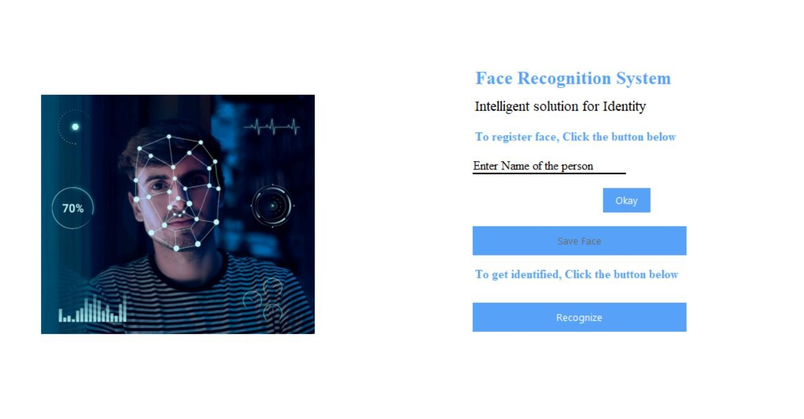
Fig 7.1.4: Setup Face Recognition Frame

7.2 Database Connection
The face recognition system establishes a secure connection to a database to store and retrieve critical information, such as user profiles, face embeddings, and recognition logs. Utilizing a relational database management system (RDBMS) like MySQL or PostgreSQL, the system employs SQL (Structured Query Language) to perform CRUD (Create, Read, Update, Delete) operations. The connection is initialized through a database driver or ORM (ObjectRelational Mapping) tool, ensuring efficient and thread-safe interactions. Upon successful connection, the system can authenticate users, store face recognition data, and retrieve relevant information for identification purposes. Furthermore, the database connection facilitates the management of user permissions, access controls, and audit trails, bolstering the overall security and integrity of the face recognition system.

7.3 Bcrypt Security
The face recognition system employs Bcrypt, a robust password hashing algorithm, to safeguard user passwords and protect against unauthorized access. Bcrypt's adaptive hashing mechanism ensures that passwords are securely stored, even in the event of a data breach. Upon user registration, passwords are hashed using a randomly generated salt, rendering rainbow table attacks ineffective. The hashed passwords are then stored in the database, replacing the original password. During authentication, the input password is hashed using the same salt and compared to the stored hash, verifying the user's identity without revealing the original password. Bcrypt's work factor, adjustable to balance security and performance, ensures that password verification is computationally expensive, thwarting brute-force attacks. This robust security measure, combined with secure password storage and transmission protocols, ensures the face recognition system's resistance to password-based attacks, safeguarding sensitive user data.
7.4 Face Recognition
There are several steps involved for face recognition.They are taken place as follows:

I. Data Collection
The data collection is crucial for gathering data necessary for face recognition models. The function captures and stores face images from a webcam, processes them in real-time, and organizes them into folders. By using a pre-trained face detection algorithm, it ensures that only face regions are saved, which helps in creating clean and focused datasets. The function also provides feedback through the GUI, showing users how many images have been captured and allowing them to monitor the progress. The collected images can later be used to train machine learning models, such as Convolutional Neural Networks (CNNs), for tasks like identifying or verifying faces.
Its working is as follows:
- User Input ValidationVerifies the username entered by the user to ensure uniqueness and validity, preventing empty or default usernames from proceeding with face image capture.
- Directory CreationCreates a unique folder for storing face images of each user within the "Faces" directory.
- Webcam InitializationEstablishes a connection to the webcam for live video capture, requiring webcam accessibility.
- Face Detection SetupLoads a pre-trained face detection model for identifying faces in video frames, aiming to capture 100 face images for training.
- GUI Update for Webcam FeedDisplays live webcam feed in the graphical user interface through continuous updates using labels.
- Webcam Feed Update and Face DetectionContinuously updates webcam feed, detects faces in each frame, converts frames to grayscale, and saves detected faces as images.
- Image Capture ProgressDisplays the number of images captured so far to track progress toward capturing the required number of images.
- Finish Image CollectionCompletes image capture process when target (100 images) is reached, turns off webcam, displays completion message, and saves images in user's folder.

Code:
def collect_faces():
# Get username and validate input username = face_name.get() if username == "Enter Name of the person" or not username:
messagebox.showerror("Invalid Name", "Please enter a valid name.")
return
# Create directory for user's face images dir_path = os.path.join('Faces', username) if not os.path.exists(dir_path):
os.makedirs(dir_path)
# Initialize webcam and face detection model cap = cv2.VideoCapture(0) face_cascade=cv2.CascadeClassifier(
cv2.data.haarcascades+'haarcascade_frontalface_default.xml'
)
# Set up GUI for webcam feed for widget in root.winfo_children():
widget.destroy()
capture_frame = Frame(root, bg='white') capture_frame.pack(fill='both', expand=True) camera_label = Label(capture_frame) camera_label.place(relx=0.5, rely=0.5, anchor='center') def update_camera_feed():
nonlocal count
ret, frame = cap.read() if not ret:
messagebox.showerror("Error", "Failed to grab frame from webcam.") cap.release()
return
# Detect faces and capture images gray = cv2.cvtColor(frame, cv2.COLOR_BGR2GRAY) faces = face_cascade.detectMultiScale(
gray, scaleFactor=1.1, minNeighbors=5, minSize=(30, 30)) faces = face_cascade.detectMultiScale(gray, scaleFactor=1.1, minNeighbors=5, minSize=(30, 30))
if len(faces) == 0:
cv2.putText(frame, "Face Not Found", (10, 20),
cv2.FONT_HERSHEY_SIMPLEX, 0.5, (0, 0, 255), 2) cv2.rectangle(frame, (10, 10), (630, 470), (0, 0, 255), 2) else: for (x, y, w, h) in faces:
cv2.rectangle(frame, (x, y), (x + w, y + h), (255, 0, 0), 2) face_region = frame[y:y + h, x:x + w] cv2.imwrite(f'{dir_path}/{count}.jpg', face_region) count += 1 cv2.putText(frame, f"Images Captured: {count}/{num_images}", (10,
40), cv2.FONT_HERSHEY_SIMPLEX, 0.5, (0, 255, 0), 2) cv2_im = cv2.cvtColor(frame, cv2.COLOR_BGR2RGB) img = Image.fromarray(cv2_im) imgtk = ImageTk.PhotoImage(image=img) camera_label.config(image=imgtk) camera_label.image = imgtk
# Update GUI and repeat until target images captured
if count <num_images:
camera_label.after(10, update_camera_feed)
else:
cap.release()
messagebox.showinfo("Image Capture", f"Image capture completed.
{num_images} images saved to {username} folder.")
setup_face_recognition_frame()
update_camera_feed()

II. Data Preprocessing
The preprocess data function handles loading face images from a directory, converting them to grayscale, resizing them to a fixed size, and normalizing them. These images are then reshaped to be suitable for input into a neural network. The function prepares both the face images and their corresponding labels, which are used for training the model. The reshaping step ensures that the images are in a format that the CNN can process, specifically with a shape that includes a single channel for grayscale. The function returns two arrays: one containing the face images and the other containing the corresponding labels.
Code:
defpreprocess_data():
faces = [] labels = [] dataset_path = "Faces"
face_cascade = cv2.CascadeClassifier(cv2.data.haarcascades +
'haarcascade_frontalface_default.xml') for folder_name in os.listdir(dataset_path):
folder_path = os.path.join(dataset_path, folder_name) if os.path.isdir(folder_path): for image_name in os.listdir(folder_path): if image_name.endswith(".jpg"):
image_path = os.path.join(folder_path, image_name) image = cv2.imread(image_path, cv2.IMREAD_GRAYSCALE)
if image is not None:
image_resized = cv2.resize(image, (100, 100)) faces.append(image_resized) labels.append(folder_name)
else:
print(f"Warning: Failed to load image {image_path}")

III. Creating the CNN Model
The create_model() function defines the architecture of the Convolutional Neural Network (CNN). A CNN is well-suited for image recognition tasks due to its ability to automatically learn spatial hierarchies of features.
- This specifies the shape of the input images. In this case, each input image is 100x100 pixels with a single color channel (grayscale). The input_shape argument defines the dimensions of the images that the model will accept as input.
- This layer applies 32 filters (or kernels) of size 3x3 to the input image. The filters are used to detect various features in the image, such as edges or textures. The activation function ReLU (Rectified Linear Unit) introduces non-linearity, allowing the model to learn more complex patterns.
- After the convolutional operation, this layer performs max pooling, which reduces the spatial dimensions of the feature maps by selecting the maximum value in a 2x2 window. This helps reduce the computational load and prevents overfitting by retaining only the most important features.
- Similar to the first convolutional layer, this layer applies 64 filters of size 3x3 to the output from the previous pooling layer. The increased number of filters helps the model learn more complex and abstract features.
- The second pooling layer further reduces the spatial dimensions of the feature maps, making the representation more compact and helping the model focus on high-level features.
- After the convolutional and pooling layers, the multi-dimensional feature maps need to be converted into a one-dimensional vector so they can be passed into the fully connected (dense) layers. The Flatten() layer does this by unrolling the 2D feature maps into a single long vector.
- This fully connected layer has 128 neurons. Each neuron is connected to every neuron from the previous layer. The ReLU activation function is applied to introduce nonlinearity and allow the model to learn complex patterns in the data.
- The final layer is a fully connected layer that produces the output. The number of neurons in this layer equals the number of classes (or unique persons in the facial recognition task). The softmax activation function is used here because it's ideal for multi-class classification problems. It converts the output into probabilities, where the sum of the probabilities across all classes is 1, and the class with the highest probability is the predicted label.
- The model is compiled with the Adam optimizer, which is an efficient optimization algorithm. The loss function used is sparse_categorical_crossentropy, which is appropriate for multi-class classification problems where the target labels are integers (as opposed to one-hot encoded labels). The model's performance will be evaluated using accuracy as the metric.
Code:
def create_model(input_shape=(100, 100, 1), num_classes=None):
model = Sequential() model.add(Conv2D(32, (3, 3), activation='relu', input_shape=input_shape)) model.add(MaxPooling2D((2, 2))) model.add(Conv2D(64, (3, 3), activation='relu')) model.add(MaxPooling2D((2, 2))) model.add(Flatten()) model.add(Dense(128, activation='relu')) model.add(Dense(num_classes, activation='softmax'))

model.compile(optimizer='adam', loss='sparse_categorical_crossentropy',
metrics=['accuracy'])
return model

IV. Training the Model
The train_model() function trains a Convolutional Neural Network (CNN) for facial recognition. First, it encodes the labels (such as names of individuals) into numeric values using LabelEncoder, which is necessary because machine learning models work with numbers, not strings.
Next, the dataset is split into training and testing sets using train_test_split(). This ensures the model is trained on 80% of the data and tested on the remaining 20%, helping to prevent overfitting and allowing the model to generalize better.
The function then creates the CNN model using the create_model() function. The model's output layer corresponds to the number of unique labels (individuals) in the dataset. It is compiled with the Adam optimizer and sparse categorical cross-entropy loss function to prepare for training.
During training, the model is trained on the training data for 20 epochs, and its performance is evaluated using the test data. This process helps the model learn patterns from the images.
After training, the model is saved as a .h5 file, containing the trained weights and architecture, so it can be used later. The LabelEncoder is also saved to ensure the same label mappings can be used for future predictions.
Code:
def train_model(faces, labels):
label_encoder = LabelEncoder() labels = label_encoder.fit_transform(labels)
X_train, X_test, y_train, y_test = train_test_split(faces, labels, test_size=0.2, random_state=42) model = create_model(num_classes=len(np.unique(labels))) model.fit(X_train, y_train, epochs=20, validation_data=(X_test, y_test))

model.save("face_recognition_model.h5") joblib.dump(label_encoder, "label_encoder.pkl") print("Model and label encoder saved.") return model, label_encoder
V. Face Detection and Recognition

• Face Detection
detect_face() function is responsible for detecting faces in a given frame. It works by first converting the frame into grayscale, which simplifies the detection process. It then uses a pre-trained facial recognition model (Haar Cascade) to scan the frame for any faces. The model identifies the locations of faces within the frame and returns bounding boxes around those faces. This is essentially the "detection" part, where the system identifies where the faces are located in the image.
• Face Recognition
After detecting the faces, the recognize_face() function goes a step further by recognizing and labeling the faces. For each detected face, the function processes the face by resizing and normalizing the image, ensuring it is in the correct format for the trained model. The model then predicts who the face belongs to by matching it against the data it has learned. If the model is confident (i.e., it has a high probability), it assigns a label (the person's name) to the face. If the model is uncertain, it labels the face as "Unknown." These labels, along with a colored bounding box, are drawn around the face in the video frame, providing real-time feedback to the user.
In essence, detect_face() finds the faces in an image, while recognize_face() goes beyond detection and identifies or classifies the faces based on the trained model. Together, they enable the system to detect and recognize individuals in real-time from a live webcam feed.
Code:
def detect_face(frame):
gray = cv2.cvtColor(frame, cv2.COLOR_BGR2GRAY) face_cascade = cv2.CascadeClassifier(cv2.data.haarcascades +
'haarcascade_frontalface_default.xml') faces = face_cascade.detectMultiScale(gray, 1.3, 5) return faces def recognize_face(frame, model, label_encoder):
faces = detect_face(frame) for (x, y, w, h) in faces:
face = frame[y:y + h, x:x + w] face_gray = cv2.cvtColor(face, cv2.COLOR_BGR2GRAY) face_resized = cv2.resize(face_gray, (100, 100)) face_normalized = face_resized / 255.0 face_normalized = face_normalized.reshape(1, 100, 100, 1) prediction = model.predict(face_normalized) label_idx = np.argmax(prediction) confidence = np.max(prediction) if confidence > 0.8: label = label_encoder.inverse_transform([label_idx])[0] color = (0, 255, 0) else:
label = "Unknown" color = (0, 0, 255) cv2.rectangle(frame, (x, y), (x + w, y + h), color, 2) cv2.putText(frame, label, (x, y - 10), cv2.FONT_HERSHEY_SIMPLEX, 0.9, color, 2) return frame

8. Model Evaluation and Results

8.1 Evaluating the model
Model evaluation metrics are required to quantify model performance. The choice of evaluation metrics depends on a given task (such as classification, regression, ranking, clustering, topic modelling, among others). Some metrics, such as precision-recall, are useful for multiple tasks. Supervised learning tasks such as classification and regression constitute a majority of applications. Let’s see some of the popular metrics to evaluate the model performance.
Confusion Matrix
A confusion matrix is a technique for summarizing the performance of a classification model.The number of correct and incorrect predictions are summarized with count values and broken down by each class. This is the key to the confusion matrix. The Figure 8.1.1 shows the interpretation of confusion matrix.
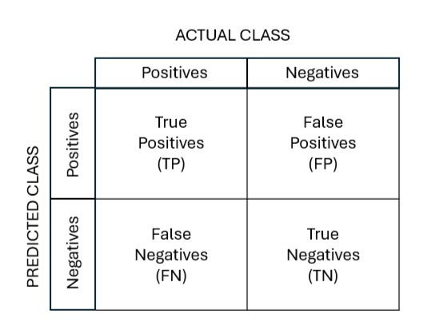
Fig 8.1.1 : Confusion Matrix
- True positives (TP): Predicted positive and are actually positive.
- False positives (FP): Predicted positive and are actually negative.
- True negatives (TN): Predicted negative and are actually negative. • False negatives (FN): Predicted negative and are actually positive.
Accuracy
Accuracy in classification problems is the number of correct predictions made by the model over all kinds predictions made. In the Numerator, are our correct predictions (True positives and True Negatives) and in the denominator, are the kind of all predictions made by the algorithm (Right as well as wrong ones).
Accuracy = (𝑇𝑃 + 𝑇𝑁)/(𝑇𝑃 + 𝐹𝑃 + 𝐹𝑁 + 𝑇𝑁)
Precision
Precision is a valid choice of evaluation metric when we want to be very sure of our prediction.
Precision = (TP)/(TP + FP)
Recall
Another very useful measure is recall, which answers a different question: what proportion of actual Positives is correctly classified?
Recall = (TP)/(TP + FN)
F1 Score
The F1 score is a number between 0 and 1 and is the harmonic mean of precision and recall.
F1 Score = (2 × Precision × Recall)/(Precision + Recall)

8.2 Results
The Face Recognition System is a GUI-based application developed using Python, OpenCV, and Tkinter. The application allows users to sign up, log in, and utilize face recognition technology to identify individuals.The application prioritized security by storing passwords securely using bcrypt hashing and salting. User data was protected against unauthorized access.
The interpretation of collection of the data is as follows As in Fig.8.2.1 a new folder for each person to save their images.
Fig.8.2.2 shows how 100 images are saved with one folder for each person in the jpg format.

Fig 8.2.1 Images collected in separate directories for each person
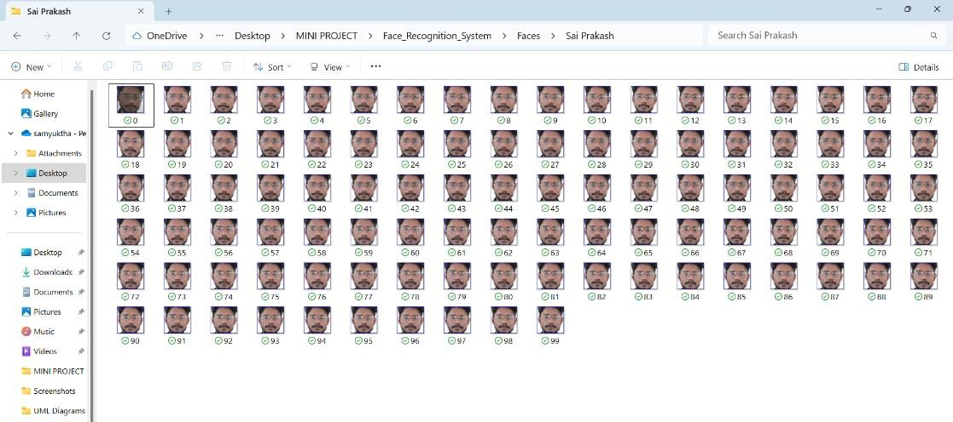
Fig 8.2.2 100 Images collected for each person
The Fig 8.2.3 and Fig 8.2.3 shows how data is collected and what how the prediction is after the training of the model.

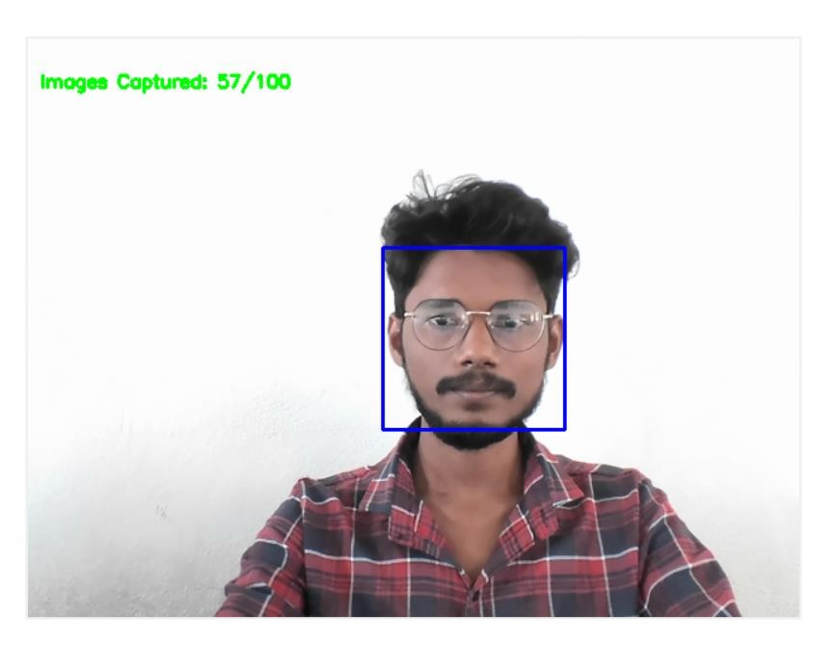
Fig 8.2.3 While collecting Images
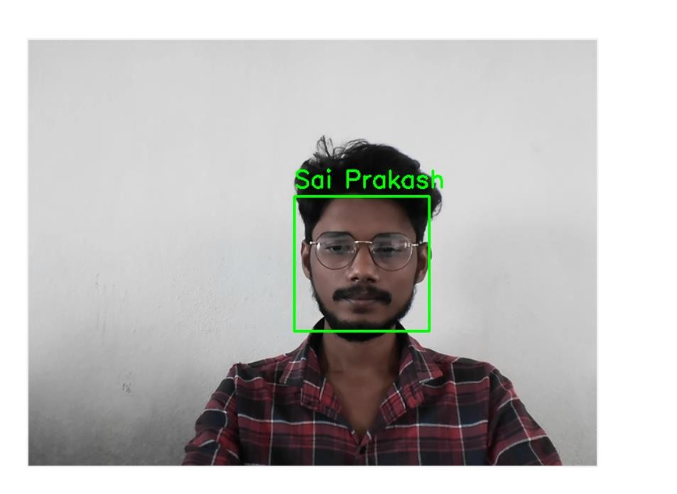
Fig 8.2.4 Face Recognition

9.FUTURE ENHANCEMEMNTS
To enhance the face recognition system, several key improvement should be considered. First, integrating multi-factor authentication by adding biometric modalities such as fingerprint, iris, or voice recognition alongside facial recognition will strengthen security and reduce the risk of spoofing. This multi-modal approach ensures a higher level of reliability and makes the system harder to bypass. Additionally, incorporating emotion and age detection through convolutional neural networks (CNNs) will extend the system’s capabilities, enabling applications in areas like sentiment analysis, customer service, and demographic profiling. For real-world deployment, a user-friendly interface through web or mobile applications will make the system easily accessible to a wider audience, while cloud or edge-based infrastructure can provide scalability and high performance, ensuring the system works efficiently in diverse environments. Security is a critical consideration, and robust measures such as data encryption, secure storage, and stringent access controls will protect sensitive user data, while clear, transparent privacy policies and user consent mechanisms will address privacy concerns. The system can be further enhanced by integrating facial attribute analysis, including the recognition of gender, ethnicity, and other facial features, which could be applied in market research, accessibility tools, and demographic studies. Expanding to videobased recognition would allow the system to track and identify individuals in real-time, improving its utility in dynamic environments. Anti-spoofing measures such as liveness detection, motion analysis, and multi-spectral imaging should be implemented to safeguard against fraudulent attempts using fake faces or 3D masks. Finally, the system can be integrated with existing infrastructure like access control systems and surveillance networks, and continuous learning mechanisms will ensure it can adapt to new faces and changing conditions, maintaining its accuracy and reliability over time.

10.CONCLUSION
“This face recognition system project successfully integrates computer vision, machine learning, and database management to provide a secure and efficient identification solution. Utilizing OpenCV, TensorFlow, and MySQL, the system captures and processes facial images, stores user data, and performs accurate recognition. The intuitive GUI, built with Tkinter, ensures user-friendly interaction. With PyInstaller, the project is deployable as a standalone executable, making it accessible on various platforms. The system demonstrates robust security features, including password hashing and secure data storage. Overall, this project showcases a well-designed and functional face recognition system suitable for various applications, including access control and surveillance.

11.BIBLIOGRAPHY
- S.Albawi, T. A. Mohammed, and S. Al-Zawi, “Understanding of a convolutional neural network,” in 2017 International Conference on Engineering and Technology (ICET). IEEE, 2017, pp. 1–6.
- G. Hu, Y. Yang, D. Yi, J. Kittler, W. Christmas, S. Z. Li, and T. Hospedales, “When face recognition meets with deep learning: an evaluation of convolutional neural networks for face recognition,” in Proceedings of the IEEE international conference on computer vision workshops, 2015, pp. 142–150.
- J. Redmon, S. Divvala, R. Girshick, and A. Farhadi, “You only look once: Unified, realtime object detection,” in Proceedings of the IEEE conference on computer vision and pattern recognition, 2016, pp. 779–788.
- A. Khan, A. Sohail, U. Zahoora, and A. S. Qureshi, “A survey of the recent architectures of deep convolutional neural networks,” arXiv preprint arXiv:1901.06032, 2019.
- A. El-Sawy, E.-B. Hazem, and M. Loey, “Cnn for handwritten Arabic digits recognition based on lenet-5,” in International conference on advanced intelligent systems and
informatics. Springer, 2016, pp. 566–575.
- Z.-W. Yuan and J. Zhang, “Feature extraction and image retrieval based on alexnet,” in Eighth International Conference on Digital Image Processing (ICDIP 2016), vol. 10033. International Society for Optics and Photonics, 2016, p. 100330E.
- M. Cos¸kun, A. Uc¸ar, O¨. Yildirim, and Y. Demir, “Face recognition based on convolutional neural network,” in 2017 International Conference on Modern Electrical and Energy Systems (MEES). IEEE, 2017, pp. 376–379.
- R. Fu, D. Wang, D. Li, and Z. Luo, “University classroom attendance based on deep learning,” in 2017 10th International Conference on Intelligent Computation Technology and Automation (ICICTA). IEEE, 2017, pp. 128–131.

